# Production Guide

2020 Winemaking Ambitions

What production challenges did you face in 2019? Be specific to challenges faced in the cellar.

Enter your answer here.

What challenges, if any, did your cellar production crew experience during the 2019 harvest season?

Enter your answer here.

What equipment broke during the 2019, or what equipment needs repair or maintenance?

Enter your answer here.

What worked well in the cellar or within your cellar team during the 2019 harvest season?

Enter your answer here.

Review your responses, above. During the 2020 year, in what ways could you better prepare to minimize the above stated challenges during the future harvest season?

Enter your answer here.

Not considering any potential limitations, what new wine/hard cider or wine product would you love to produce in 2020?

Enter your answer here.

What new equipment or technology would you like to invest in, in 2020? Think of potential technologies that may eliminate some of the challenges stated above. Or, list equipment/technologies that you know would improve the operational quality of your business.

Enter your answer here.

**Finish this sentence:**

I heard/read a lot about Insert your answer here. in the wine industry, and I would like to know more about it.

**Have you:**

|  |  |
| --- | --- |
| Cleaned and sanitized all seasonal harvest equipment? | Choose an item. |
| Cleaned and sanitized the crush pad floor and walls since the end of harvest? | Choose an item. |
| Repaired any damaged harvest equipment? | Choose an item. |
| Updated your inventory (i.e., tossed expired enological products and properly disposed of expired laboratory chemicals, replace and ordered needed supplies)? | Choose an item. |
| Confirmed the free and total sulfur dioxide concentration of wines in storage and/or in barrel since the start of 2020? | Choose an item. |
| Confirmed that your 2019 wines have completed primary fermentation (i.e., test the residual sugar)? | Choose an item. |
| Confirmed that your 2019 wines have completed malolactic fermentation, if desired (i.e., test the residual malic acid concentration)? | Choose an item. |
| Updated the production records for 2019 wines? | Choose an item. |
| Completed any regulatory records that are annually required? | Choose an item. |

# Next Steps

Now that you have officially reflected on the 2019 year, it’s time to move forward in the right direction for 2020. You can review the [Post-Harvest Checklist Timeline](https://www.dgwinemaking.com/portfolio/production-guide-post-harvest-prep/) to make sure you’re staying on track to properly plan for the coming year. Remember, good winemaking practices include maintaining cellar momentum every week.

Then, using your answers above, you can use the next steps to accomplish great things in 2020:

1. It’s time to get a head start on 2020! **Complete any of the tasks you answered “No” to in the last series of questions.** They may not be your favorite tasks but completing them now will help incentivize you to complete additional tasks in the cellar during this slow time of year.
2. **Create a list of items or technologies** you may want to review during the upcoming conference season. Check the annual budget and make sure there is room for you to purchase new items.
   1. Many vendors offer deals or incentives from January through April to entice wineries to make purchases early and avoid the harvest crunch time.
   2. Something outside of your budget this year? Create a [DGW Classified Want Ad](https://www.dgwinemaking.com/classifieds/), which gets distributed throughout the DG Winemaking network. Perhaps you can find an item second-hand at a fraction of the price!
3. Look at the type of wine, hard cider, or wine product you would like to try to make this year. **This “slow” time of year is when you should get to planning how to accomplish that wine in 2020**. There’s a list of resources on [*dgwinemaking.com*](https://www.dgwinemaking.com/) that can help you plan out a number of wines:
   1. [Pét-Nats](https://www.dgwinemaking.com/portfolio/pet-nats/)
   2. [White and Rose Table Wines](https://www.dgwinemaking.com/portfolio/pre-bottling-prep-white-wine/)
   3. [Red Table Wines](https://www.dgwinemaking.com/portfolio/pre-bottling-prep-red-wine/)
   4. [Formula Wines](https://www.dgwinemaking.com/portfolio/production-guide-pre-bottling-prep-for-formula-wine/) and [Formula Wine Ingredients](https://www.dgwinemaking.com/portfolio/formulating-untraditional-wines-and-wine-products/)
   5. [Sparkling Wines](https://www.dgwinemaking.com/portfolio/coming-may-20th-its-all-about-that-base-sparkling-wine-production-details/)
   6. [Wines from rotted fruit](https://www.dgwinemaking.com/portfolio/coming-march-26th-creatively-perfecting-wines-from-challenging-vintages/)
   7. [Appassimento](https://www.dgwinemaking.com/portfolio/improving-red-wine-concentration-appassimento/) Techniques
   8. Need help spurring some ideas? Watch the webinar on [Creative Wine Styles for Hybrid Wines](https://www.dgwinemaking.com/portfolio/october-creative-wine-styles-for-hybrid-varieties/)
4. Finally, **what did you want to learn more about this year?** Make it your goal to find information on this topic once a week. Maybe spend the first 15 minutes (or the last 15 minutes) of every Monday searching for something new on that topic, opening a textbook, or reaching out to industry experts for more content. Search the [*dgwinemaking.com* Blog](https://www.dgwinemaking.com/category/blog-posts/), as many winemaking topics are covered there and provide free access.

# Professional Services

Of course, if you’re ready to learn and keep a professional resource handy, consider investing in a 12-month [Darn Good Winemakers membership](https://www.dgwinemaking.com/product/darn-good-winemakers-400/). Darn Good Winemakers meet twice monthly during a one-hour *Winemaking Advice Hour* in which you can ask ANY winemaking question you may have. Questions can also be specific to your operation. And, you can continue learning wine improvement techniques through monthly webinars posted in the [Darn Good Winemakers page](https://www.dgwinemaking.com/portfolio-type/darn-good-winemakers/) as well as exclusive email content for members only.

Is 2020 the year you’re ready take your wine production to the next level? Inquire today ([info@dgwinemaking.com](mailto:info@dgwinemaking.com)) about [DG Winemaking Consulting Packages](https://www.dgwinemaking.com/consulting-packages/) available for you to reach your winemaking goals. There’s something for everyone and every budget! No production is too small for advancement. The introductory, DEMI, package opens all of the content listed, above!

You can read more about consulting benefits, [here](https://www.dgwinemaking.com/services/), and how DG Winemaking is helping other wineries just like yours, [here](https://www.dgwinemaking.com/client-testimonials/)!

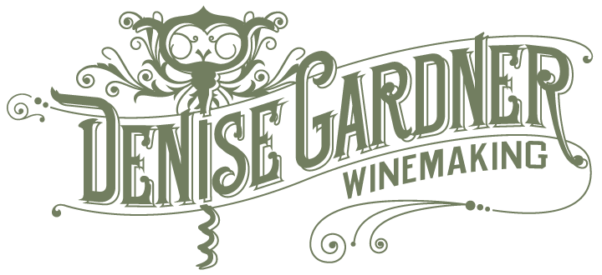

### WWW.DGWINEMAKING.COM

### COPYRIGHT 2020 • ALL RIGHTS RESERVED